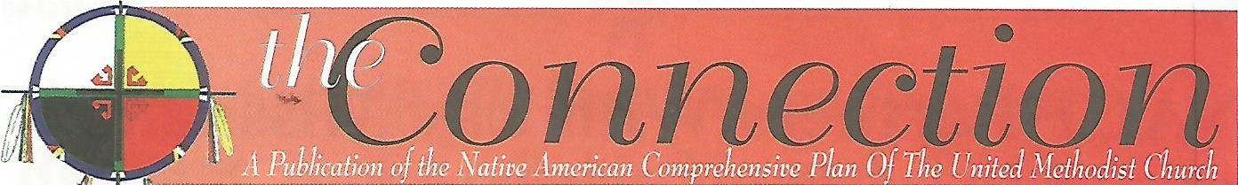

Spring 2017

Tapalot Native American Fellowship Serves the Local Community
The Tapalot Native American Fellowship was founded three years ago in
Indianapolis, Indiana. The word “Tapalot” means love in the Miami language.
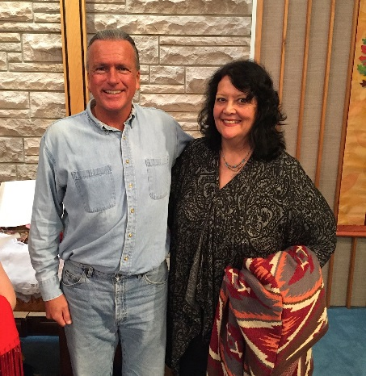
The Fellowship is sponsored by St. Andrew UMC of the Indiana Conference and
works in cooperation with the Indiana Conference Committee on Native
American Ministries. NACP has provided consultation and resourcing over the
years to the Indiana Conference, the CONAM and Tapalot Fellowship.
A little over two years ago, Tapalot Fellowship began an outreach
ministry called “Bread of Life”. This ministry began through a partnership with a
local bakery distributor. It began small and has now grown by leaps and bounds.
Founded by congregation member, Leo Canfield, and Tapalot Fellowship Lay
Missioner, Linda Madagame, the ministry provides free bakery products once a
month to persons on the SE side of the city of Indianapolis. This is the area of the
city with the highest number of Native Americans in residence, as well as many
people of all races and ethnicities who struggle with poverty. Bread of Life
Tapalot Fellowship Lay Missioner, Linda Madagame, and Michael Jacobs, Cherokee singer, at community cultural event.
ministers to everyone who comes for assistance. The food distribution began with six regular volunteers and thirty people served. Through an increase in volunteers and donations, Tapalot Native American Fellowship/St Andrew UMC were able to add a free hot meal for those coming to the ministry each month. Over 1,300 families and individuals were served in 2016.
Additionally, a partnership developed between the Fellowship and the Miami Nation of Indians in Peru, IN. The Miami Nation of Indians is a state-recognized tribe of Indigenous People. Each month a truckload of bakery products are delivered to this highly impoverished community. The tribe has a rotation of fifteen volunteers who serve within this project. At the end of 2016 over 960 families and 2,900 individuals in need within this community had been served and had received love and hospitality from Tapalot Fellowship and St. Andrew UMC.

Blackfeet United Methodist Parish Hosts Reservation/Community Campmeeting
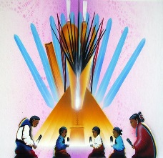
The fall of 2016 saw a cold north wind blowing across northern Montana and across the Blackfeet United Methodist Parish (BUMP) at Browning, MT. It was time for what has become an annual event during the tenure of the present pastor, Rev. Calvin Hill. He and his wife, Sheri, and their family live on the BUMP Ranch where they raise cattle and horses and farm alfalfa as part of the BUMP ministry. Income from the ranch helps fund the ministries of BUMP, including the three Blackfeet Reservation UM churches.

The annual event last fall was the Intertribal Campmeeting, an old-time tent revival, which was held on the ranch. The NACP Director, Rev. Anita Phillips, served as the Bible Study Leader for the Campmeeting and she taught from United Methodist Lay Speaking resources. Preachers and speakers came from all denominations represented on the Blackfeet Reservation, as well as much inclusion of Native American cultural ways. Rev. Hill specifically designed the Campmeeting with the intention of uniting all faith communities. He is of the Dine’ Nation (Navajo) and throughout the event shared much of his traditional beliefs and Christian witness.
Rev. Phillips had the opportunity to learn much about the BUMP ministries and was happy to learn that Rev. Hill was working hard to lead the congregations in revitalization of the reservation churches. As a part of the 2016 NACP ministry, funding was provided to BUMP to assist with fall evangelistic and community activities.

ON THIS SPIRIT WALK
A Small Group Resource Available for Enlightenment and Study
A resource created to educate and challenge readers about the journey of Native American and Indigenous United Methodists is available through NACP. On This Spirit Walk (OTSW) utilizes the voices of many leaders from
Native and Indigenous communities to tell their stories of faith, challenge and hope. Each of the twelve chapters
serves as a vehicle to focus on topics essential to the worldview of these Nations and the way in which
Christian and traditional cultural values have impacted their experiences.
Many churches have used this resource as the basis for a twelve-week small group study.
OTSW is available for $12 per copy which includes shipping. Contact the NACP office at nacomp@prodigy.net to order.

New Ministry with Native American United Methodist Men On the Way!
NACP will be starting a new program to encourage the growth and development of United Methodist Men’s activities in Native churches and communities. Program announcement to come later this year.

NACP is an Advance special mission project of the UMC. 100% of your gift will be used for NACP ministry with Native American communities and churches. To give online, go to UMCmission.org/Give-to-Mission/The-Advance and enter our project# 982615. Thank you for walking with us!
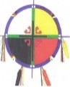
2017 CONAM Conference
During the first year of every new quadrennium, NACP sponsors a gathering of U.S. Annual Conference Committees on Native American Ministries (CONAM). This event provides training and resourcing to CONAM members and annual conference staff who work with CONAM’s. The 2017 CONAM Conference is being cosponsored by the Greater New Jersey Conference CONAM and will be held in Vineland, NJ on Sept 29-Oct 1. Folks will fly in to Philadelphia International Airport and take a shuttle to the conference hotel. Highlights of the conference include the opportunity to share with and learn from those engaged in this vital and unique ministry; Native American leaders who will speak on topics of current concern and an outing to the Nanticoke Lenni-Lenape Tribal Nation Grounds. To request registration materials, contact the NACP office at nacomp@prodigy.net .

2017 Native American Writers Gathering—Is the Creator Calling You to Share Your Story?
A New Native American Youth Church School Curriculum in the Works
NACP is actively engaged in a writing partnership which will result in a new weekly curriculum for Native American youth. Tentatively called “Eagle Flights”, each weekly session of the curriculum will include a story from the life of a Native American United Methodist, Scripture references, group activities, real life applications, and worship materials. Both a youth book and a leader’s guide will be available.
At the present time, stories are being collected for the curriculum. The 2017 Writers Gathering, a regular event sponsored by NACP for Native American writers, will focus on producing written stories for the new Eagle Flights Curriculum. The NACP 2017 Writers Gathering will take place during Family Camp in Gore, Oklahoma on July 24-27, 2017. Family Camp is an event for Native American families and individuals sponsored by the Native American International Caucus (NAIC). Through the collaboration of NAIC and NACP, persons can take part in either or both events this summer. For further information about taking part in the 2017 Writers Gathering, contact the NACP office.

NACP Project Aims at Training Laity for Starting New Fellowships and Reaching New People
The development of new worship and faith communities for Native American people is a major focus of NACP. An ongoing project to aid in this focus is the Native American Discipleship Network. At present, a new curriculum for Native American laity is under development, with plans in the works for sharing this project with annual conferences, DS’s and existing Native churches and ministries. The team working on the curriculum include Native American writers from each of the U.S. jurisdictions. The new curriculum will include original material written by team members, as well as material adapted from Path One resources. Look for an update on this resource later on this year.
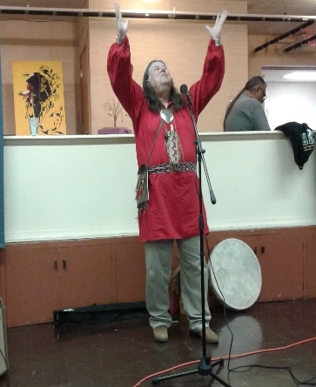
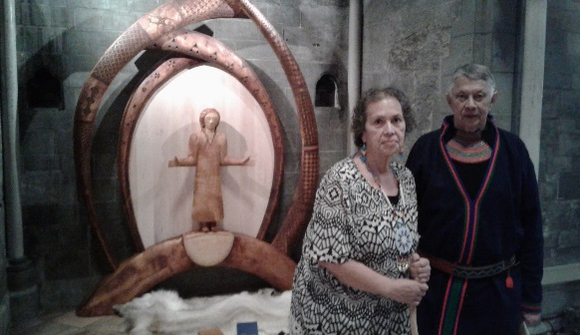
(right) Rev. Fred Shaw (Shawnee), master storyteller and NACP Board member, shares a story at the 2016 Native American Discipleship Conference in Milwaukee, WI. This was the first time for NACP to host this event. Conference co-sponsor was the NCJ CONAM.
(left)Standing before the traditional Sami altar in the Nicados Cathedral in Trondheim, Norway are Rev. Anita Phillips, NACP Director and Sami artist, Folke Fjallstrom, creator of the altar. The altar was a gift from the Sami People to the country of Norway.

NACP Takes Part in Sami People’s Celebration and New Indigenous Global Network
In February of 2017 a group of Indigenous United Methodists from around the world gathered in Norway to attend the celebration of the 100th anniversary of the first Sami People’s Congress. The Sami are indigenous to Norway, Finland, Sweden and Russia. Many continue to herd reindeer, live migratory lifestyles and speak the Sami language. A high note of Methodist history in Norway was the momentous decision of the congregation of the Trondheim UMC to open their doors to the first Sami People’s Congress 100 years ago when other churches were not willing to offer this hospitality. “The opportunity to worship and celebrate along with this congregation and many Sami relations and representatives was a memorable experience”, commented Rev. Anita Phillips. NACP Board Member, Ragghi Calentine, was also a part of the Native American delegation. She shared, “It was such an amazing sight to witness hundreds of Sami, dressed in their beautiful traditional attire, walking down the streets of Trondheim, Norway.” A week of celebration events was held across the country.
A second purpose of the gathering in Norway of Indigenous United Methodists from around the world was the founding of a new Indigenous Global Network within the UMC. People from the Philippines, Africa, Asia, Europe and the U.S. took part in these historic early conversations. Plans have been devised for future gatherings and follow up work together. This significant journey to Norway was organized by Church and Society and included NAIC, NACP, United Methodist Women, World Council of Churches, Global Ministries and many others.

Giving Tuesday This Year Will be November 28, 2017
Giving Tuesday is a growing movement to create an international day of charitable giving at the beginning of the fall holiday shopping season in response to commercialization and consumerism (think Black Friday and Cyber Monday). 2017 will be the 6th year of celebrating Giving Tuesday. NACP hopes you will mark Nov 28, 2017 on your calendar and remember us, as well as other UM organizations on this day set aside for doing good to your neighbors. You may support NACP by giving through the Advance Program of Global Ministries, Advance# 982615. Creator God bless you!

You may contact NACP at: 928 N.York St., Muskogee, OK 74403
Phone – (918) 686-8444 Fax – (918) 686-8456 Email – nacomp@prodigy.net

