NACP Takes Part in Native American Theological Task Force

The General Board of Higher Education and Ministry (GBHEM) has formed a new team entrusted with the task of planning and forming a new Educational Service Center for Native American United Methodists. The Native American Theological Task Force (NATTF) was formed eighteen months ago and membership includes Rev. Anita Phillips, NACP Director; Cynthia Kent, NAIC Chairperson; Rev. Chebon Kernell, Executive Secretary of Native American and Indigenous Ministries, GBGM; and Rev. David Martinez, GBHEM Director of Programs of Theological Education. ESC’s are Disciplinary entities serving various racial-ethnic groups. Their purpose is the recruitment, training and retention of clergy and lay leadership. NATTF membership will soon expand to include two additional representatives from each U.S. jurisdiction. Future work of NATTF will focus on leadership development and work with UM seminaries.

Native American Writers Gathering Held in Portland

Portland, Oregon was the site for a gathering of Native American writers sponsored by NACP in October, 2015. Twenty-two writers participated in this event and included Native persons of all ages from youth through elders. Activities included structured writing sessions as well as field trips designed to inspire the imaginations of the writers. One such field trip was a bus ride through the Columbia River Gorge accompanied by an indigenous storyteller who told stories and gave witness to his life’s journey along the gorge. The event facilitator for the gathering was Kimberlee Medicine Horn Jackson (Yankton Dakota) a writer and editor who consults with Kent State University.
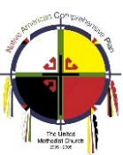
Published by the Native
Native American Comprehensive Plan of
The United Methodist Church

Mailing address:
928 N. York, Ste. 2
Muskogee, OK 74403
Office: 918-686-8444
Fax: 918-686-8456
nacomp@prodigy.net

Executive Director
Rev. Anita Phillips

Administration Assistant
Cheryl Hensley

The NACP is an
Advance Special.
Your Advance gift
To NACP enables
The Plan to strengthen
United Methodist
Rural and reservation
Ministries across the
Church.
Advance #982615

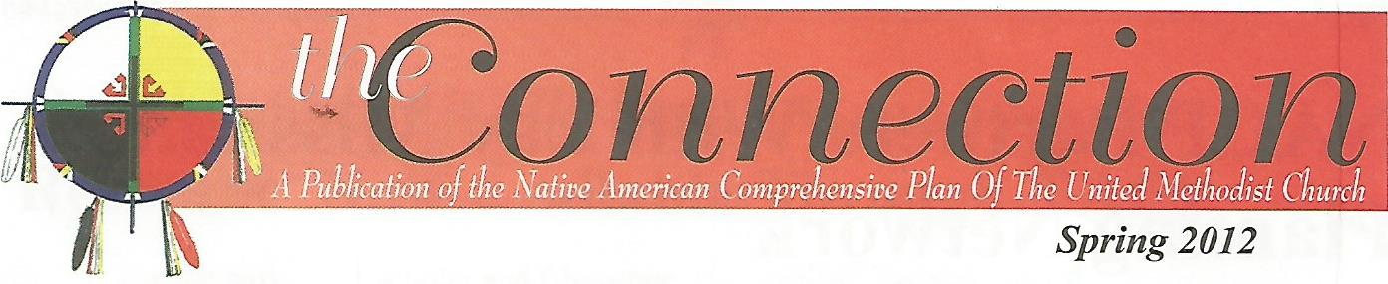

Spring 2016

Native American Heritage Month Honored by Discipleship Ministries

November is designated as Native American Heritage Month in the U.S. To commemorate this special designation, Discipleship Ministries partners with NACP to educate and raise awareness of staff members regarding Native Americans. In November, 2015 NACP Director, Rev. Anita Phillips, preached for the Upper Room Chapel Service. NACP Administrative Assistant, Cheryl Hensley, also participated in the service by sharing her testimony about the ministry of NACP. A special luncheon was hosted by the General Secretary of Discipleship Ministries, Rev. Tim Bias, and Rev. Phillips spoke to the staff gathered for the shared meal. Ms. Hensley (Choctaw) and Rev. Phillips (Keetoowah Cherokee) wore their tribal attire during their presentations. “We appreciate being able to coordinate with Discipleship Ministries to Honor this special month”, stated Ms. Hensley.
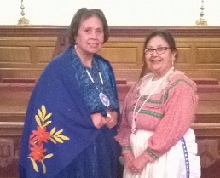
“Anita and Cheryl wearing their
Cherokee and Choctaw attire.”

NACP Hosts New Fellowships Summit
NACP sponsored an exciting new event with co-host, the Oklahoma Indian Missionary Conference in November, 2015. Over 50 persons met at Mosaic United Methodist Church in Oklahoma City to listen, learn, share and encourage one another. Participants came from a cross-section of tribes and nations and from urban, rural and reservation settings. Rev. Doug Ruffle, staff from Path One/New Church Starts of Discipleship Ministries shared information and strategies from across the United Methodist connection.

Native American clergy and lay leaders working within new fellowship settings led sessions highlighting their ministries. Participants visited both the North OKC Fellowship, a new congregation, and the Angie Smith UMC, a revitalizing congregation. NACP plans to host a follow-up event in the 2017-2020 quadrennium.

Work Begins on Native American Lay Disciple Planting Curriculum

A team of Native American leaders have begun their work on development of a curriculum aimed at training laypersons for starting new fellowships. Team members are culturally adapting some materials developed by Path One/New Church Starts of Discipleship Ministries, as well as creating new material for the curriculum. Team members represent tribes from across the five U.S. jurisdictions and include Rev. Charles Brower (Inupiaq) from the WJ, Pamela Baker (Lumbee) from the SEJ, Cynthia Kent (Southern Ute) from the NEJ, Rev. Adrienne Trevathan (Port Gamble S’Klallam) from the NCJ, Rev. Julienne Judd (Kiowa/Choctaw) from the SCJ and Rev. Anita Phillips (Keetoowah Cherokee), NACP Director. Work is anticipated to continue through 2016 with the curriculum completed by January, 2017. NACP will seek funding to underwrite the utilization of the new curriculum for the training of Native American laypersons.

NACP works with Annual Conference Services of Repentance

Rev. Anita Phillips, NACP Director, has been working with several annual conferences during the 2013-2016 quadrennium as they develop and complete Services of Repentance for Healing Relationships with Native American peoples. These conferences include Oregon-Idaho, Rocky Mountain, Oklahoma, Minnesota, and North Alabama. Rev. Phillips will also be teaching workshops related to Acts of Repentance for the Wisconsin Conference in June, 2016 and will focus on the book, On This Spirit Walk. This book was produced by NACP and was utilized by the 2012 General Conference to educate delegates on Acts of Repentance related to harm done to Native Americans.

Native American Course of Study (NACOS)

Course of Study Schools are offered through UM seminaries and are an educational option that local pastors may choose in order to fulfill requirements for ordination as elders and deacons. A Native American Course of Study School (NACOS) has been developed in the NCJ and has been educating both Native and non-Native pastors across the UMC for over ten years. Chaired by Rev. Fred Shaw (Shawnee), an NACP board member, NACOS is in session twice a year and is held in locations throughout Indian Country. The most recent session was hosted by the Oneida Nation of Wisconsin. NACP’s Director, Rev. Anita Phillips serves on the NACOS Advisory Board and stated, “This is one of the most significant developments for Native American United Methodists. Offering seminary education within a Native context is invaluable.”
Leadership Development Offered Through Native American Lay Servant Academy

In April of 2016 forty persons gathered at Mt. Sequoyah Retreat Center in Fayetteville, Arkansas for a Lay Servant and Leadership Academy. Basic lay servant training and advanced training were offered. The advance courses included Worship Leader and Storytelling. Leadership skills were emphasized throughout the event.

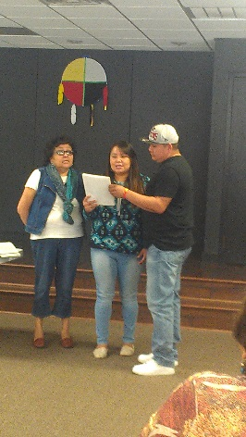
“Marty Long,
OJ and Vanessa Mark
share a Dine’ hymn.”
